**A Project report on**

**ANOMALYXPERT: A DEEP LEARNING APPROACH TO ANOMALY DETECTION**

###### A Dissertation submitted to JNTU Hyderabad in partial fulfilment of the academic requirements for the award of the degree.

**Bachelor of Technology**

**in**

**Computer Science and Engineering**

Submitted by

G. PRANEETH

(20H51A0510)

A.ABHINAV

(20H51A0505)

C. HARISHWAR

(20H51A05B9)

Under the esteemed guidance of

**(Ms.B. Gayathri)**

**(Assistant Professor)**

**(DEPT. OF CSE)**



**Department of Computer Science and Engineering**

# CMR COLLEGE OF ENGINEERING AND TECHNOLOGY

(An Autonomous Institution under UGC & JNTUH, Approved by AICTE, Permanently Affiliated to JNTUH, Accredited by NBA.)

KANDLAKOYA, MEDCHAL ROAD, HYDERABAD-501401.

**2020- 2024**



# CMR COLLEGE OF ENGINEERING & TECHNOLOGY

KANDLAKOYA, MEDCHAL ROAD, HYDERABAD – 501401

## DEPARTMENT OF COMPUTER SCIENCE AND ENGINEERING



# CERTIFICATE

This is to certify that the Major Project Phase-1 report entitled **"AnomalyXpert: A Deep Learning Approach to Anomaly Detection”** being submitted by **G.Praneeth(20H51A0510),A.Abhinav(20H51A0505),HarishwarReddy(20H51A05B9),**in partial fulfilment for the award of **Bachelor of Technology in Computer Science and Engineering** is a record of bonafide work carried out his/her under my guidance and supervision.

The results embody in this project report have not been submitted to any other University or Institute for the award of any Degree.

**Ms.B.GAYATHRI Dr. S. SIVA SKANDHA**

**Assistant Professor Associate Professor and HOD**

**Dept. of CSE Dept. of CSE**

## ACKNOWLEDGEMENT

With great pleasure We want to take this opportunity to express my heartfelt gratitude to all the people who helped in making this project work a grand success.

We are grateful to **Ms.B.Gayathri,** Assistant Professor, Dept of Computer Science and Engineering for his valuable technical suggestions and guidance during the execution of this project work.

We would like to thank **Dr. S. Siva Skandha,** Head of the Department of Computer Science and Engineering, CMR College of Engineering and Technology, who is the major driving forces to complete my project work successfully.

We are very grateful to **Dr. Vijaya Kumar Koppula**, Dean-Academic, CMR College of Engineering and Technology, for his constant support and motivation in carrying out the project work successfully.

We are highly indebted to **Dr. V. A. Narayana,** Principal, CMR College of Engineering and Technology, for giving permission to carry out this project in a successful and fruitful way.

We would like to thank the **Teaching & Non- teaching** staff of Department of Computer Science and Engineering for their co-operation

Finally We express our sincere thanks to **Mr. Ch. Gopal Reddy**, Secretary, CMR Group of Institutions, for his continuous care. We sincerely acknowledge and thank all those who gave support directly and indirectly in completion of this project work.

(Student Name) (Roll No)

G.PRANEETH (20H51A0510)

A.ABHINAV (20H51A0505)

C.HARISHWAR REDDY (20H51A05B9)



## DECLARATION

We hereby declare that results embodied in this Report of Project on

**“ANOMALYXPERT:A DEEP LEARNING APPROACH TO ANOMALY DETECTION”** are from work carried out by using partial fulfilment of the requirements for the award of B. Tech degree. We have not submitted this report to any other university/institute for the award of any other degree.

### NAME SIGNATURE

G.PRANEETH

A.ABHINAV

C.HARISHWAR REDDY

## TABLE OF CONTENTS

|  |  |  |  |
| --- | --- | --- | --- |
| **CHAPTERS** | | **DESCRIPTION** | **PAGE No** |
|  |  | **ABSTRACT** | **1** |
| **1** |  | **INTRODUCTION** | **2 -3** |
|  | 1 | Introduction | 3 |
| **2** |  | **BACKGROUNDWORK** | **4-5** |
|  | 2 | Background work | 5 |
|  | 2.1 | Existing solutions | 5 |
| **3** |  | **PROPOSED SYSTEM** | **6-8** |
|  | 3.1 | Proposed solution | 7 |
|  | 3.2 | Description | 7 |
|  | 3.3 | System Requirements | 8 |
| **4** |  | **DESIGNING** | **9-16** |
|  | 4.1 | Input and Output Design | 10 |
|  | 4.2 | Architecture Diagram | 11 |
|  | 4.3 | UML Diagrams | 11-13 |
|  | 4.4 | Source Code | 13-16 |
| **5** |  | **RESULTS AND DISCUSSIONS** | **17-25** |
|  | 5.1 | Types Of Test | 18-19 |
|  | 5.2 | Test Strategy and approach | 19-20 |
|  | 5.3 | Screenshots of execution | 20-25 |
| **6** |  | **CONCLUSION AND FUTURE SCOPE** | **26-28** |
|  | 6.1 | Conclusion | 27 |
|  | 6.2 | Future Scope | 27 |
|  | 6.3 | References | 28 |

## FIGURES

|  |  |  |  |  |
| --- | --- | --- | --- | --- |
|  | **CHAPTER** | | **NAME** | **PAGE NO** |
| **5.3** |  |  | **Screenshots of Execution** | **21-26** |
|  |  | 5.3.1 | run | 21 |
|  |  | 5.3.2 | CMD dialog box | 22 |
|  |  | 5.3.3 | Interface for the project | 22 |
|  |  | 5.3.4 | Uploading a CCTV video | 23 |
|  |  | 5.3.5 | Generating frames | 23 |
|  |  | 5.3.6 | Generated frames | 24 |
|  |  | 5.3.7 | Detecting suspicious activity frames | 24 |
|  |  | 5.3.8 | Detected frames of suspicious activity | 25 |
|  |  | 5.3.9 | Frames folder | 25 |
|  |  | 5.3.10 | Frames of video can be found | 26 |

## ABSTRACT

Surveillance security is a very tedious and time-consuming job, by this project we will build a system to automate the task of analysing video surveillance. We will analyse the video feed in real-time and identify any abnormal activities like violence or theft. There is a lot of research going on in the industry about video surveillance among them; the role of CCTV videos has overgrown. CCTV cameras are placed all over the places for surveillance and security. In the last decade, there have been advancements in deep learning algorithms for deep surveillance. These advancements have shown an essential trend in deep surveillance and promise a drastic efficiency gain. The typical applications of deep surveillance are theft identification, violence detection, and detection of the chances of explosion, and the possibility to identify the abnormal activities without a man work It is helpful in a way it reduces the time of analysing the surveillance videos and also reduces the man power to observe a video and it effectively detects a abnormal activity where most of the solutions can be found.

# CHAPTER 1

## INTRODUCTION

### 1. INTRODUCTION

Human face and human behavioural pattern play an important role in person identification. Visual information is a key source for such identifications. Surveillance videos provide such visual information which can be viewed as live videos, or it can be played back for future references. The recent trend of ‘automation’ has its impact even in the field of video analytics. Video analytics can be used for a wide variety of applications like motion detection, human activity prediction, person identification, abnormal activity recognition, vehicle counting, people counting at crowded places, etc. In this domain, the two factors which are used for person identification are technically termed as face recognition and gait recognition respectively.

Among these two techniques, face recognition is more versatile for automated person identification through surveillance videos. Face recognition can be used to predict the orientation of a person’s head, which in turn will help to predict a person’s behaviour. Motion recognition with face recognition is very useful in many applications such as verification of a person, identification of a person and detecting presence or absence of a person at a specific place and time. In addition, human interactions such as subtle contact among two individuals, head motion detection, hand gesture recognition and estimation are used to devise a system that can identify and recognize suspicious behaviour among pupil in an examination hall successfully. This paper provides a methodology for suspicious human activity detection through face recognition.

Video processing is used in two main domains such as security and research. Such a technology uses intelligent algorithms to monitor live videos. Computational complexities and time complexities are some of the key factors while designing a real-time system. The system which uses an algorithm with a relatively lower time complexity, using less hardware resources and which produces good results will be more useful for time-critical applications like bank robbery detection, patient monitoring system, detecting and reporting suspicious activities at the railway station, etc Manual monitoring of exam hall through invigilators and manual monitoring of exam hall through surveillance videos is performed throughout the world. Monitoring an examination hall is a very challenging task in terms of man power. Manual monitoring of examination halls may be prone to error during human supervision. Such a system when implemented as an ‘automatic suspicious activity detection system’ will not only help in detecting suspicious activities but also helps in minimizing such activities. Moreover, the probability of error will be much lesser.

And hence prevents passing incriminating material among students. In our research, we have contributed upon a system that will intellectually process live video of examination halls with students and classify their activities as suspicious or not. This research proposes an intelligent algorithm that can monitor and analyse the activities of students in an examination hall and can alert the educational institute’s administration on account of any malpractices/suspicious activities.

# CHAPTER 2

## BACKGROUND WORK

### 2. BACKGROUND WORK

1.Input Design is the process of converting a user-oriented description of the input into a computer-based system. This design is important to avoid errors in the data input process and show the correct direction to the management for getting correct information from the computerized system.

2. It is achieved by creating user-friendly screens for the data entry to handle large volume of data. The goal of designing input is to make data entry easier and to be free from errors. The data entry screen is designed in such a way that all the data manipulates can be performed. It also provides record viewing facilities.

3.When the data is entered it will check for its validity. Data can be entered with the help of screens. Appropriate messages are provided as when needed so that the user will not be in maize of instant. Thus the objective of input design is to create an input layout that is easy to follow

#### 2.1 EXISTING SOLUTIONS

The existing solutions for the problem statement are

→CCTV surveillance camera

→security cameras

→security guards

##### Drawbacks in existing system

The major limitations of existing schemes are as follows: -

* The cc tv surveillance cameras needs a human to check the ongoing issues a continue focus on screen to be required.
* The security cameras needs to store the data in an order so that the issues can be only recorded to further evidence .
* The continues watching of the cc tv footage by a human cannot detect an abnormal

event due to some human error .

* And the present existing solutions is a time consuming process.

# CHAPTER 3

## PROPOSED SYSTEM

### 3. PROPOSED SYSTEM

**3.1 PROPOSED SOLUTION:**

The proposed solution is **abnormal activity detection using deep learning** which detects the abnormal activity .

#### 3.2 DESCRIPTION

The proposed solution is a basic idea from training a model and implementing it i.e we created a model which is trained with the abnormal activities such as thefts and some crimes and the testing model has a created its own memory to which it should identify and the solution for the problem is solved and it saves the big storages to be saved and it also help to find the problem easily so that the human power need not used which saves lot of time .

##### Advantages of Proposed solution

* The proposed solutions saves the time which a human spend on finding a problem is

CCTV footages .

* The proposed solution saves the CCTV footages into a frames which is easy to find

the problem and also it saves the frames as images .

* The proposed solution can easily train and test a video from which the problem should

be detected and which problem should be found .

#### 3.3 SYSYEM REQUIREMENTS

**3.3.1 HARDWARE REQUIREMENTS :**

For developing the application the following are the Hardware Requirements:

HARDWARE SPECIFICATION : SERVER

PROCESSOR : Pentium IV or higher RAM RAM : 256 MB

HARD DISK : minimum 512MB

**3.3.2 SOFTWARE REQUIREMENTS:**

OPERATING SYSTEM : WINDOWS 7/8/10

PLATFORM : VISUAL STUDIO CODE

PROGRAMMING LANGUAGE : Python

SOFTWARE REQUIREMENTS : Python , Django , My sql , Wampserver

# CHAPTER 4

## DESIGNING

### 4.DESIGNING

**4.1 INPUT AND OUTPUT DESIGN**

#### INPUT DESIGN

The input design is the link between the information system and the user. It comprises the developing specification and procedures for data preparation and those steps are necessary to put transaction data in to a usable form for processing can be achieved by inspecting the computer to read data from a written or printed document or it can occur by having people keying the data directly into the system. The design of input focuses on controlling the amount of input required, controlling the errors, avoiding delay, avoiding extra steps and keeping the process simple. The input is designed in such a way so that it provides security and ease of use with retaining the privacy. Input Design considered the following things:

* What data should be given as input?
* How the data should be arranged or coded?
* The dialog to guide the operating personnel in providing input.
* Methods for preparing input validations and steps to follow when error occur.

##### OBJECTIVES

1.Input Design is the process of converting a user-oriented description of the input into a computer-based system. This design is important to avoid errors in the data input process and show the correct direction to the management for getting correct information from the computerized system.

2. It is achieved by creating user-friendly screens for the data entry to handle large volume of data. The goal of designing input is to make data entry easier and to be free from errors. The data entry screen is designed in such a way that all the data manipulates can be performed. It also provides record viewing facilities.

3.When the data is entered it will check for its validity. Data can be entered with the help of screens. Appropriate messages are provided as when needed so that the user will not be in maize of instant. Thus the objective of input design is to create an input layout that is easy to follow

##### OUTPUT DESIGN

A quality output is one, which meets the requirements of the end user and presents the information clearly. In any system results of processing are communicated to the users and to other system through outputs. In output design it is determined how the information is to be displaced for immediate need and also the hard copy output. It is the most important and direct source information to the user. Efficient and intelligent output design improves the system’s relationship to help user decision-making.

1. Designing computer output should proceed in an organized, well thought out manner; the right output must be developed while ensuring that each output element is designed so that people will find the system can use easily and effectively. When analysis design computer output, they should Identify the specific output that is needed to meet the requirements.

2.Select methods for presenting information.

* 1. **ARCHITECTURE DIAGRAM:**

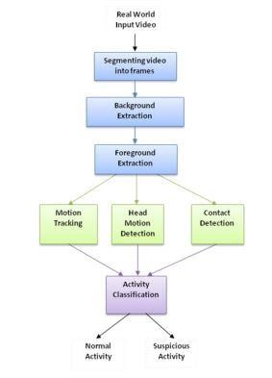

* 1. **UML DIAGRAMS:**

**CLASS DIAGRAM:**

In software engineering, a class diagram in the Unified Modeling Language (UML) is a type of static structure diagram that describes the structure of a system by showing the system's classes, their attributes, operations (or methods), and the relationships among the classes. It explains which class contains information.

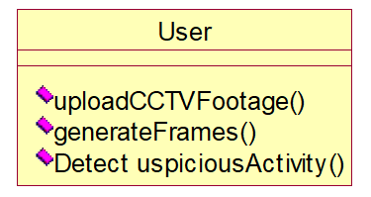

**USE CASE DIAGRAM:**

A use case diagram in the Unified Modeling Language (UML) is a type of behavioural diagram defined by and created from a Use-case analysis. Its purpose is to present a graphical overview of the functionality provided by a system in terms of actors, their goals (represented as use cases), and any dependencies between those use cases. The main purpose of a use case diagram is to show what system functions are performed for which actor. Roles of the actors in the system can be depicted.

Upload CCTV Footage

generate Frames

User

Detect Suspicious Activity

**SEQUENCE DIAGRAM:**

A sequence diagram in Unified Modeling Language (UML) is a kind of interaction diagram that shows how processes operate with one another and in what order. It is a construct of a Message Sequence Chart.

Sequence diagrams are sometimes called event diagrams, event scenarios, and timing diagrams.

|  |  |  |
| --- | --- | --- |
| User |  | Application |

upload cctv footage

generate frames

Detect Suspicious Activity

**Collaboration Diagram:**

1: upload cctv footage

2: generate frames

3: Detect Suspicious Activity

User

Applicati

on

**4.4 CODE:**

#pip install ImageAi==2.0.3 from tkinter import messagebox from tkinter import * from tkinter import simpledialog import tkinter from tkinter import filedialog from imutils import paths import matplotlib.pyplot as plt import datetime from tkinter.filedialog import askopenfilename import cv2 import shutil import os

from imageai.Prediction.Custom import CustomImagePrediction import os import winsound

main = tkinter.Tk() main.title("Suspicious Activity Detection") main.geometry("1200x1200")

global filename

execution_path = os.getcwd() prediction = CustomImagePrediction() prediction.setModelTypeAsResNet() prediction.setModelPath("model.h5") prediction.setJsonPath("model_class.json") prediction.loadModel(num_objects=2) def beep():

frequency = 2500 # Set Frequency To 2500 Hertz duration = 1000 # Set Duration To 1000 ms == 1 second winsound.Beep(frequency, duration)

def upload(): global filename filename = askopenfilename(initialdir = "videos") pathlabel.config(text=filename)

def generateFrame(): global filename text.delete('1.0', END) if not os.path.exists('frames'):

os.mkdir('frames') else:

shutil.rmtree('frames') os.mkdir('frames') vidObj = cv2.VideoCapture(filename) count = 0 success = 1 while success:

success, image = vidObj.read() if count < 500:

cv2.imwrite("frames/frame%d.jpg" % count, image) text.insert(END,"frames/frame."+str(count)+" saved\n") print("frames/frame."+str(count)+" saved")

#pathlabel.config(text="frames/frame."+str(count)+" saved") else:

break count += 1 pathlabel.config(text="Frame generation process completed. All frames saved inside frame folder")

def detectActivity():

imagePaths = sorted(list(paths.list_images("frames"))) count = 0 option = 0; text1.delete('1.0', END) for imagePath in imagePaths:

predictions, probabilities = prediction.predictImage(imagePath, result_count=1) for eachPrediction, eachProbability in zip(predictions, probabilities): if float(eachProbability) > 80:

count = count + 1; if float(eachProbability) < 80:

count = 0 if count > 10: option = 1 beep()

+" is predicted as "+eachPrediction+" with probability : " +str(eachProbability)) print(imagePathtext1.insert(END,imagePath+" is predicted as "+eachPrediction+" with

probability : " +str(eachProbability)+"\n\n") count = 0;

print(imagePath+" processed") if option == 0:

text1.insert(END,"No suspicious activity found in given footage")

font = ('times', 20, 'bold') title = Label(main, text='Suspicious Activity Detection From CCTV Footage') title.config(bg='brown', fg='white') title.config(font=font) title.config(height=3, width=80) title.place(x=5,y=5)

font1 = ('times', 14, 'bold')

upload = Button(main, text="Upload CCTV Footage", command=upload) upload.place(x=50,y=100) upload.config(font=font1)

pathlabel = Label(main) pathlabel.config(bg='brown', fg='white') pathlabel.config(font=font1) pathlabel.place(x=300,y=100)

depthbutton = Button(main, text="Generate Frames", command=generateFrame) depthbutton.place(x=50,y=150) depthbutton.config(font=font1)

userinterest = Button(main, text="Detect Suspicious Activity Frame", command=detectActivity) userinterest.place(x=280,y=150) userinterest.config(font=font1)

font1 = ('times', 12, 'bold') text=Text(main,height=25,width=50) scroll=Scrollbar(text) text.configure(yscrollcommand=scroll.set) text.place(x=10,y=200) text.config(font=font1)

text1=Text(main,height=25,width=50) scroll=Scrollbar(text1)

text1.configure(yscrollcommand=scroll.set) text1.place(x=550,y=200) text1.config(font=font1)

main.config(bg='green') main.mainloop()

# CHAPTER 5

## RESULTS AND DISCUSSIONS

### 5. RESULTS AND DISCUSSIONS

### 

#### SYSTEM TEST

The purpose of testing is to discover errors. Testing is the process of trying to discover every conceivable fault or weakness in a work product. It provides a way to check the functionality of components, sub assemblies, assemblies and/or a finished product It is the process of exercising software with the intent of ensuring that the Software system meets its requirements and user expectations and does not fail in an unacceptable manner. There are various types of test. Each test type addresses a specific testing requirement.

#### 5.1TYPES OF TESTS

##### 5.1.1 Unit testing

Unit testing involves the design of test cases that validate that the internal program logic is functioning properly, and that program inputs produce valid outputs. All decision branches and internal code flow should be validated. It is the testing of individual software units of the application .it is done after the completion of an individual unit before integration. This is a structural testing, that relies on knowledge of its construction and is invasive. Unit tests perform basic tests at component level and test a specific business process, application, and/or system configuration. Unit tests ensure that each unique path of a business process performs accurately to the documented specifications and contains clearly defined inputs and expected results.

##### 5.1.2Integration testing

Integration tests are designed to test integrated software components to determine if they actually run as one program. Testing is event driven and is more concerned with the basic outcome of screens or fields. Integration tests demonstrate that although the components were individually satisfaction, as shown by successfully unit testing, the combination of components is correct and consistent. Integration testing is specifically aimed at exposing the problems that arise from the combination of components.

###### 5.1.3 Functional test

Functional tests provide systematic demonstrations that functions tested are available as specified by the business and technical requirements, system documentation, and user manuals.

Functional testing is based on the following items:

Valid Input : identified classes of valid input must be accepted.

Invalid Input : identified classes of invalid input must be rejected.

Functions : identified functions must be exercised.

Output : identified classes of application outputs must be exercised.

Systems/Procedures : interfacing systems or procedures must be invoked.

Organization and preparation of functional tests is focused on requirements, key functions, or special test cases. In addition, systematic coverage pertaining to identify Business process flows; data fields, predefined processes, and successive processes must be considered for testing. Before functional testing is complete, additional tests are identified and the effective value of current tests is determined.

###### 5.1.4System Test

System testing ensures that the entire integrated software system meets requirements. It tests a configuration to ensure known and predictable results. An example of system testing is the configuration oriented system integration test. System testing is based on process descriptions and flows, emphasizing pre-driven process links and integration points.

5.1.5 White Box Testing

White Box Testing is a testing in which in which the software tester has knowledge of the inner workings, structure and language of the software, or at least its purpose. It is purpose. It is used to test areas that cannot be reached from a black box level.

5.1.6 Black Box Testing

Black Box Testing is testing the software without any knowledge of the inner workings, structure or language of the module being tested. Black box tests, as most other kinds of tests, must be written from a definitive source document, such as specification or requirements document, such as specification or requirements document. It is a testing in which the software under test is treated, as a black box .you cannot “see” into it. The test provides inputs and responds to outputs without considering how the software works.

5.2 Test strategy and approach

Field testing will be performed manually and functional tests will be written in detail.

**Test objectives**

* All field entries must work properly.
* Pages must be activated from the identified link.
* The entry screen, messages and responses must not be delayed.

**Features to be tested**

* Verify that the entries are of the correct format
* No duplicate entries should be allowed
* All links should take the user to the correct page.

5.2.1 Integration Testing

Software integration testing is the incremental integration testing of two or more integrated software components on a single platform to produce failures caused by interface defects.

The task of the integration test is to check that components or software applications, e.g. components in a software system or – one step up – software applications at the company level – interact without error.

**Test Results:** All the test cases mentioned above passed successfully. No defects encountered.

5.2.2 Acceptance Testing

User Acceptance Testing is a critical phase of any project and requires significant participation by the end user. It also ensures that the system meets the functional requirements.

**Test Results:** All the test cases mentioned above passed successfully. No defects encountered.

**5.3 Screenshots of Execution:**

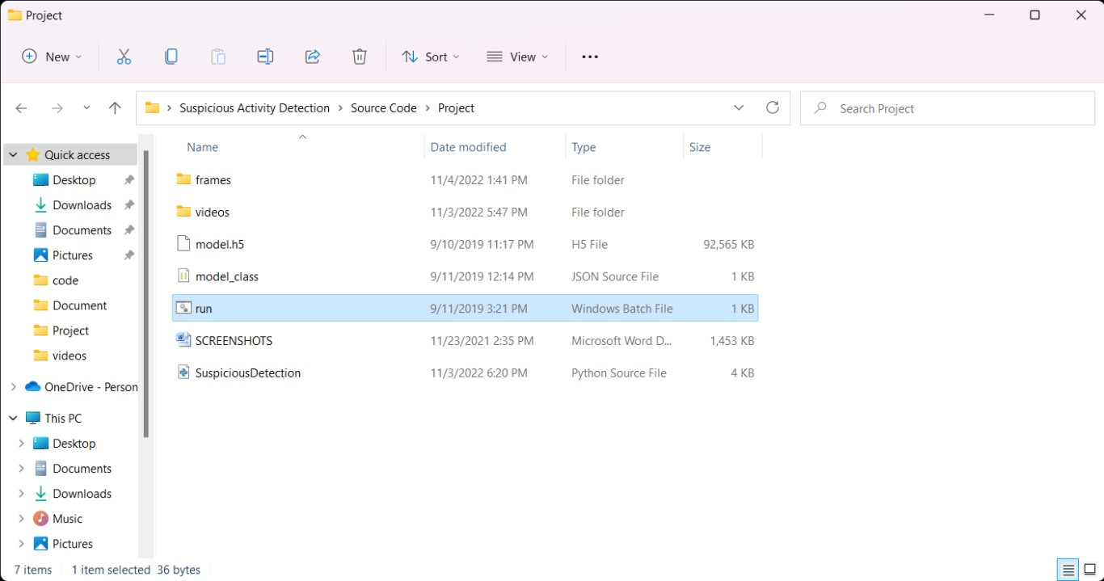

##### Fig 5.3.1

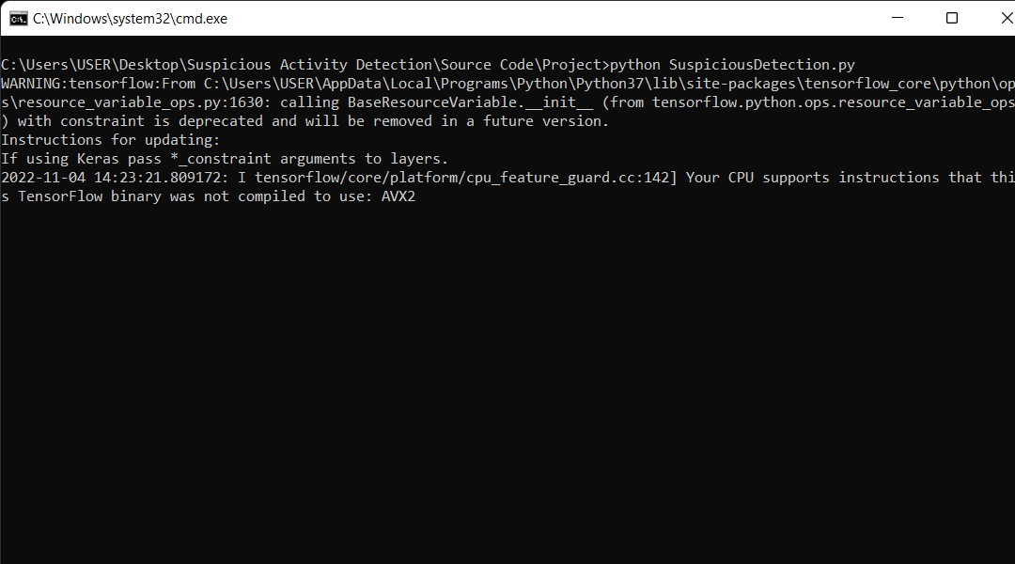**Fig 5.3.2**

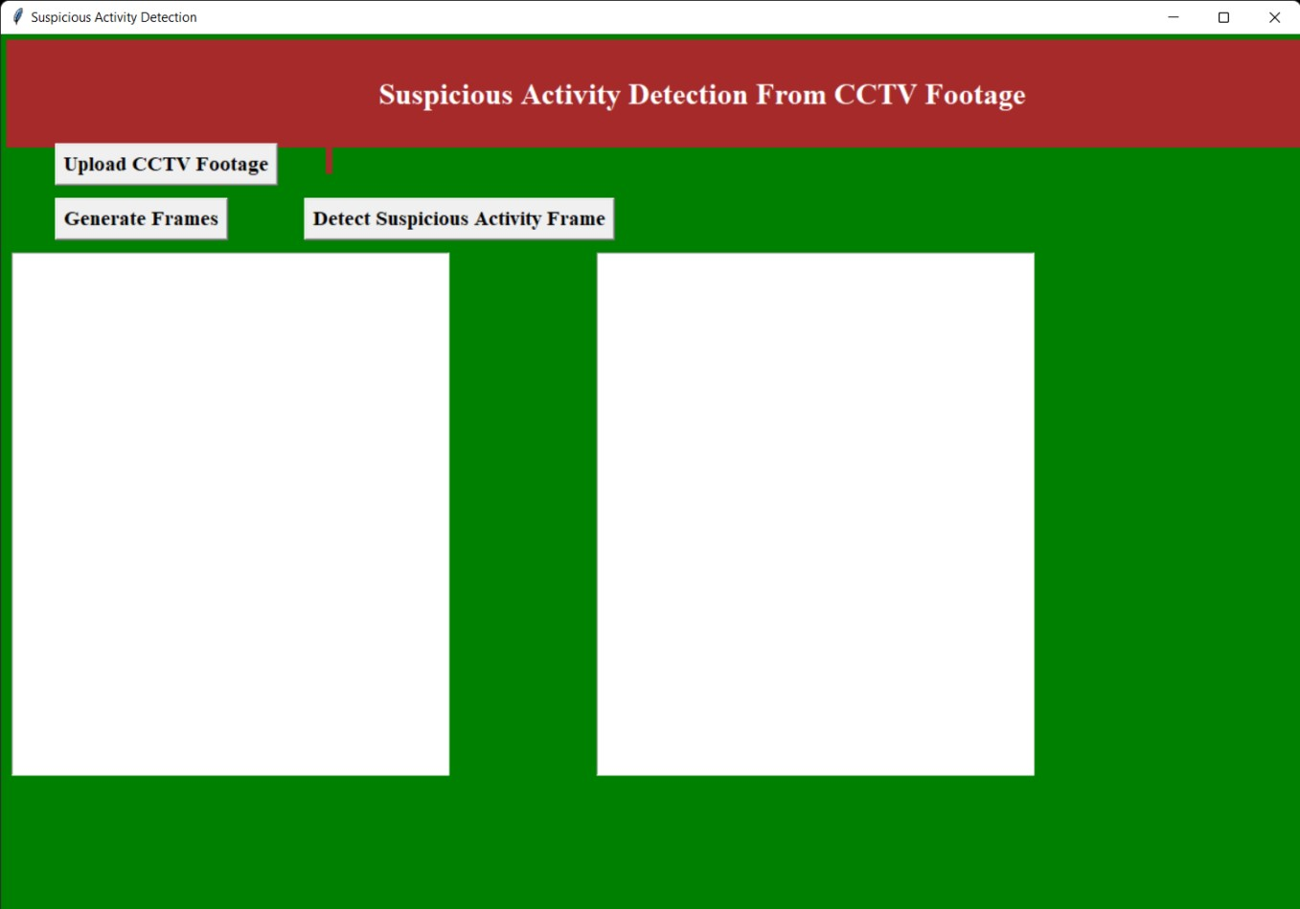**Fig 5.3.3**

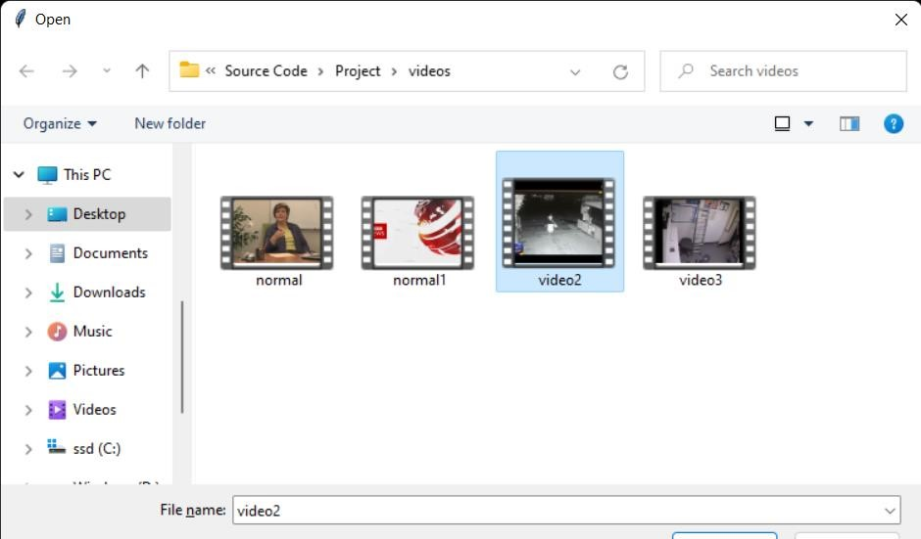

**Fig 5.3.4**

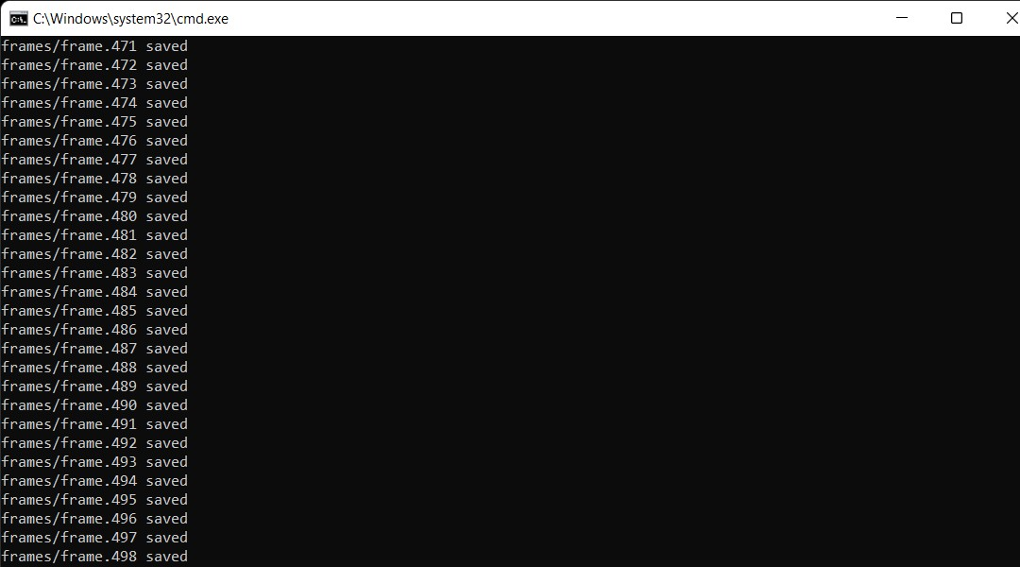

**Fig 5.3.5**

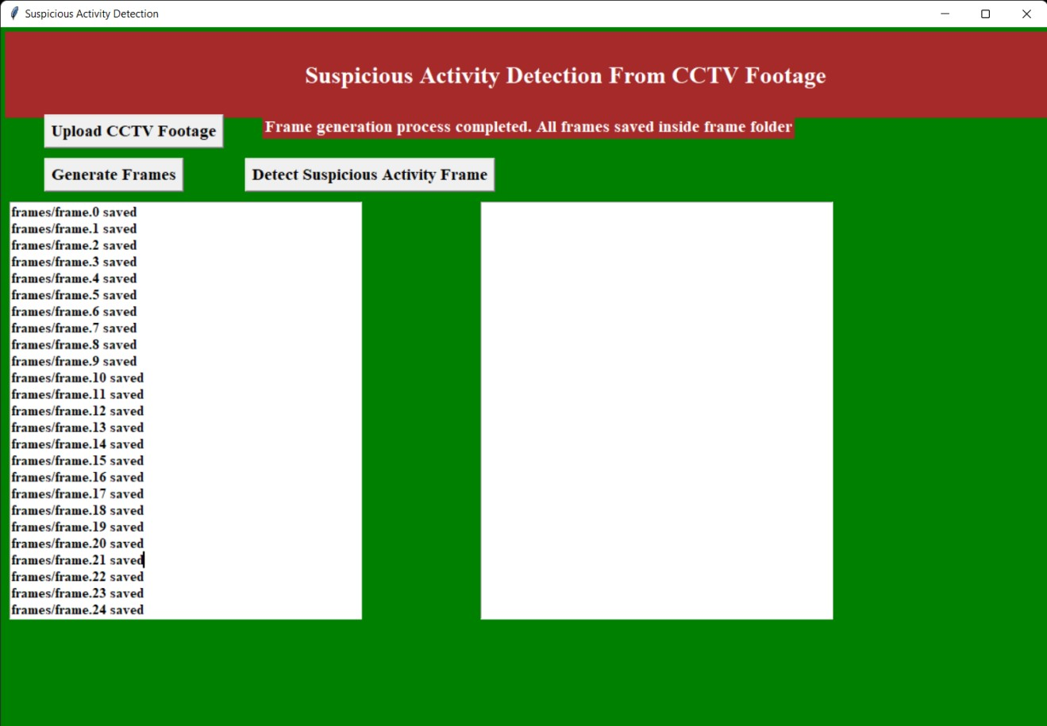**Fig 5.3.6**

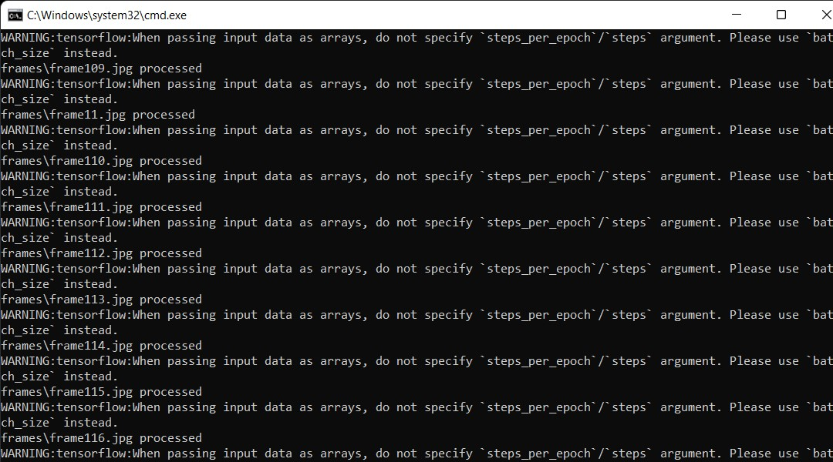

**Fig 5.3.7**

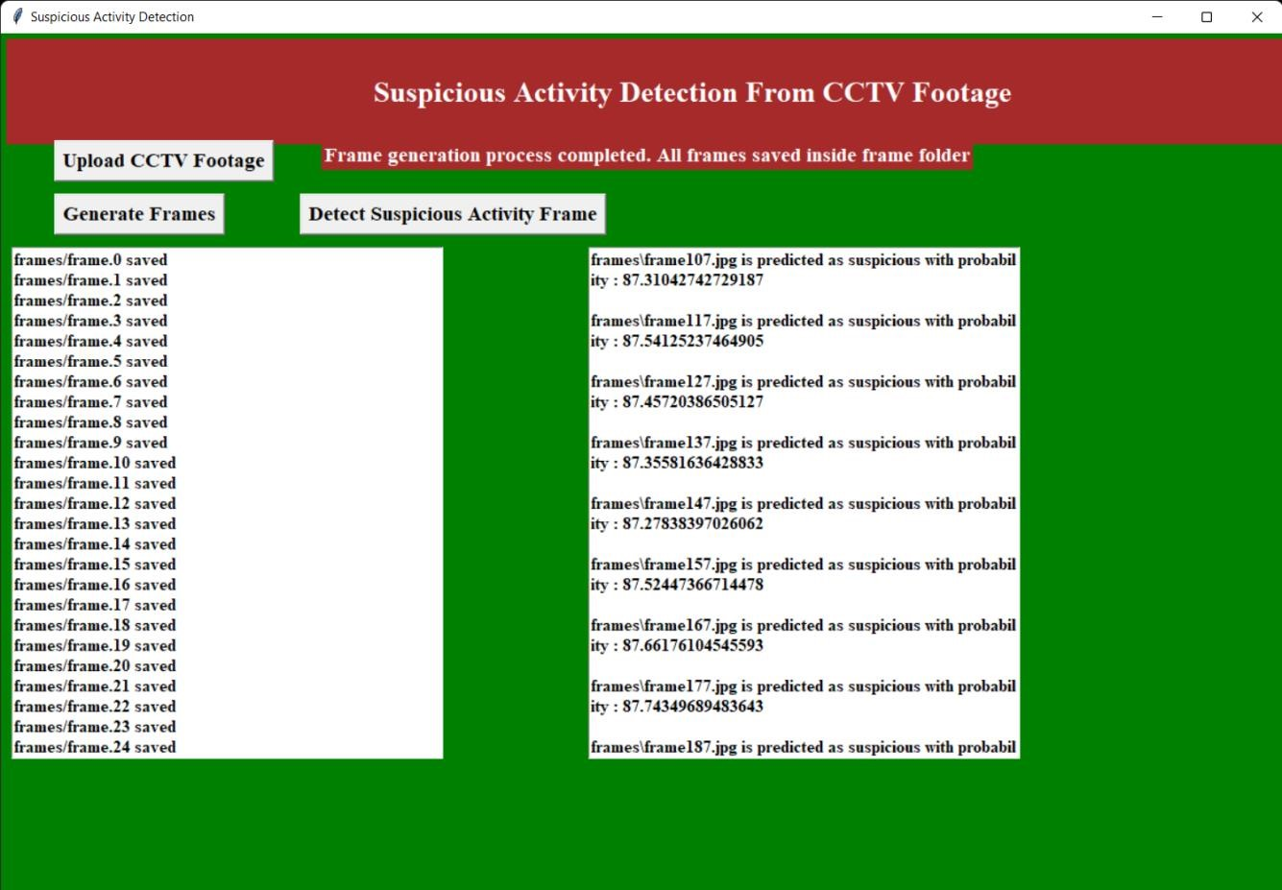**Fig 5.3.8**

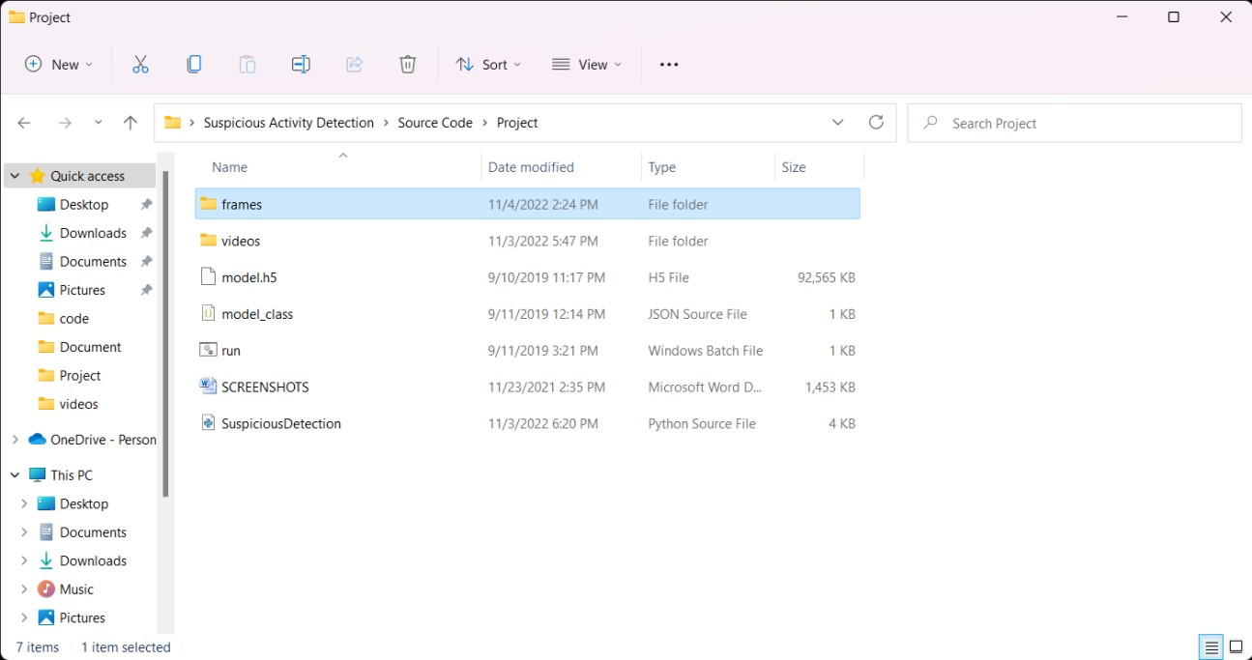**Fig5.3.9**

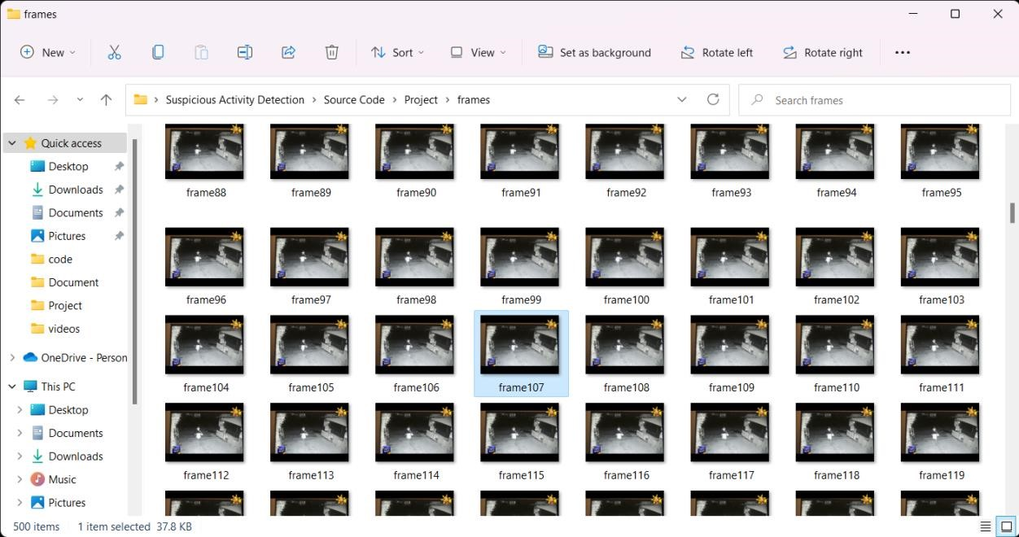

**Fig 5.3.10**

**CHAPTER 6**

## CONCLUSION AND FUTURE WORK

### 6.1 CONCLUSION

In present world, almost all the people are aware of the importance of CCTV footages, but most of the cases these footages are being used for the investigation purposes after a crime/incident have been happened. The proposed model has the benefit of stopping the crime before it happens. The real time CCTV footages are being tracked and analysed. The result of the analysis is a command to the respective authority to take an action if in case the result indicates an untoward incident is going to happen. Hence this can be stopped. Even though the proposed system is limited to academic area, this can also be used to predict more suspicious behaviours at public or private places. The model can be used in any scenario where the training should be given with the suspicious activity suiting for that scenario. The model can be improved by identifying the suspicious individual from the suspicious activity.

**6.2 FUTURE SCOPE:**

→This project can be taken to further level by implementing a real time network and live suspicious activity detection

→This project can be further updated to work in mobile app versions where a video can be uploaded

→In future this project can be used to detect the activities which are threat to mankind

→In future this project can be updated to a version where the live frames of abnormal

activities will be sent to the persons email or whatsapp

→This project can be taken to further level by just as a interface use where we can detect the specific activity by training the model

### 6.3 REFERENCES

* <https://github.com/Poornav/Unusual-Human-Activity-Detection>
* [https://medium.com/@gevariyamaulik05/abnormal-human-activity-](https://medium.com/@gevariyamaulik05/abnormal-human-activity-detection-c01c73760982)

[detectionc01c73760982](https://medium.com/@gevariyamaulik05/abnormal-human-activity-detection-c01c73760982)

* <https://www.ijraset.com/research-paper/abnormal-crowd-detection-in-public-places>
* [https://github.com/LeadingIndiaAI/Armed-Injured-and-other-Suspicious-ActivityRecognition-using-Drone-Surveillance](https://github.com/LeadingIndiaAI/Armed-Injured-and-other-Suspicious-Activity-Recognition-using-Drone-Surveillance)